26 AUGUST 2026

SEPTEMBER 2026 GRADUATION: GENERIC GRADUATION GUIDELINES

Dear Graduand
Congratulations on successfully fulfilling the academic requirements for your qualification. In recognition of this important milestone and its significance for your future academic and professional journey, Walter Sisulu is pleased to host the forthcoming in-person graduation ceremony for you and your family.
Kindly be advised that the University will hold the graduation ceremony in person.

The University acknowledges the value of graduation ceremonies for you and your families, as well as the implications for your future professional and academic plans. Please take note of the following important arrangements relating to the ceremony and the issuance of your degree, diploma, or certificate:
Confirmation of Graduation Status
Graduands are requested to confirm their graduation status on the Walter Sisulu Student Portal using their student number and PIN.
Verification of Personal Details
Certification details are generated automatically from the information provided during the initial online application for admission to Walter Sisulu. You are therefore requested to verify that your full names correspond exactly with those reflected on your Identity Document. Should any discrepancy be identified, you are advised to contact the Administration Office on your campus without delay, and no later than 11 September 2026, to make the necessary corrections.

Graduation Ceremony Details
Walter Sisulu will confer all degrees, diplomas, and certificates centrally at the Nelson Mandela Drive (NMD), Great Hall, Mthatha campus on Friday, 25 September 2026.
Faculty and qualification-specific schedules are available on page 4 of this communication and on the University website. The official graduation programme, listing all graduands by faculty and by session, will also be published on the University website. In addition, individualised invitation letters will be sent directly to each graduand’s registered email address.
Guest Access
Each graduand is permitted to invite a maximum of two guests. Please note that additional family members or guests will not be allowed access to the campus. However, they will be able to view the ceremony online from their homes.
E-Tickets
The University will issue electronic tickets for admission to the ceremony. Your access e-ticket, together with those of your two guests, will be available for download from a link provided on the graduation webpage from 16 September 2026.
Academic Dress
All graduands are required to wear the appropriate academic dress, comprising a gown, hood, and mortarboard, relevant to their qualification. The order form, provided by the University’s officially appointed service provider, House of Graduates, is available on the University website.
Financial Clearance
Please note that your degree, diploma, or certificate will be released only once all outstanding financial obligations to the University have been settled. For account-related inquiries, please contact the relevant campus office as follows:

Mthatha: | studentdebtorsmth@wsu.ac.za
Butterworth: | studentdebtorsbtw@wsu.ac.za
Komani: | studentdebtorskom@wsu.ac.za
Buffalo City Campus: | studentdebtorsbcc@wsu.ac.za

Special Needs
Graduands with specific physical requirements or accessibility needs are requested to inform the Examinations Department in advance so that the necessary arrangements may be made.
Additional Notes
Please note that no refreshments will be provided at the ceremony. Academic records will remain accessible online via the Student Portal using your student number and PIN. Graduands are also encouraged to complete the graduation survey in order to provide feedback on their academic and student experience.

Graduate Destination Survey 2026 – Fill out the form
QR Code:
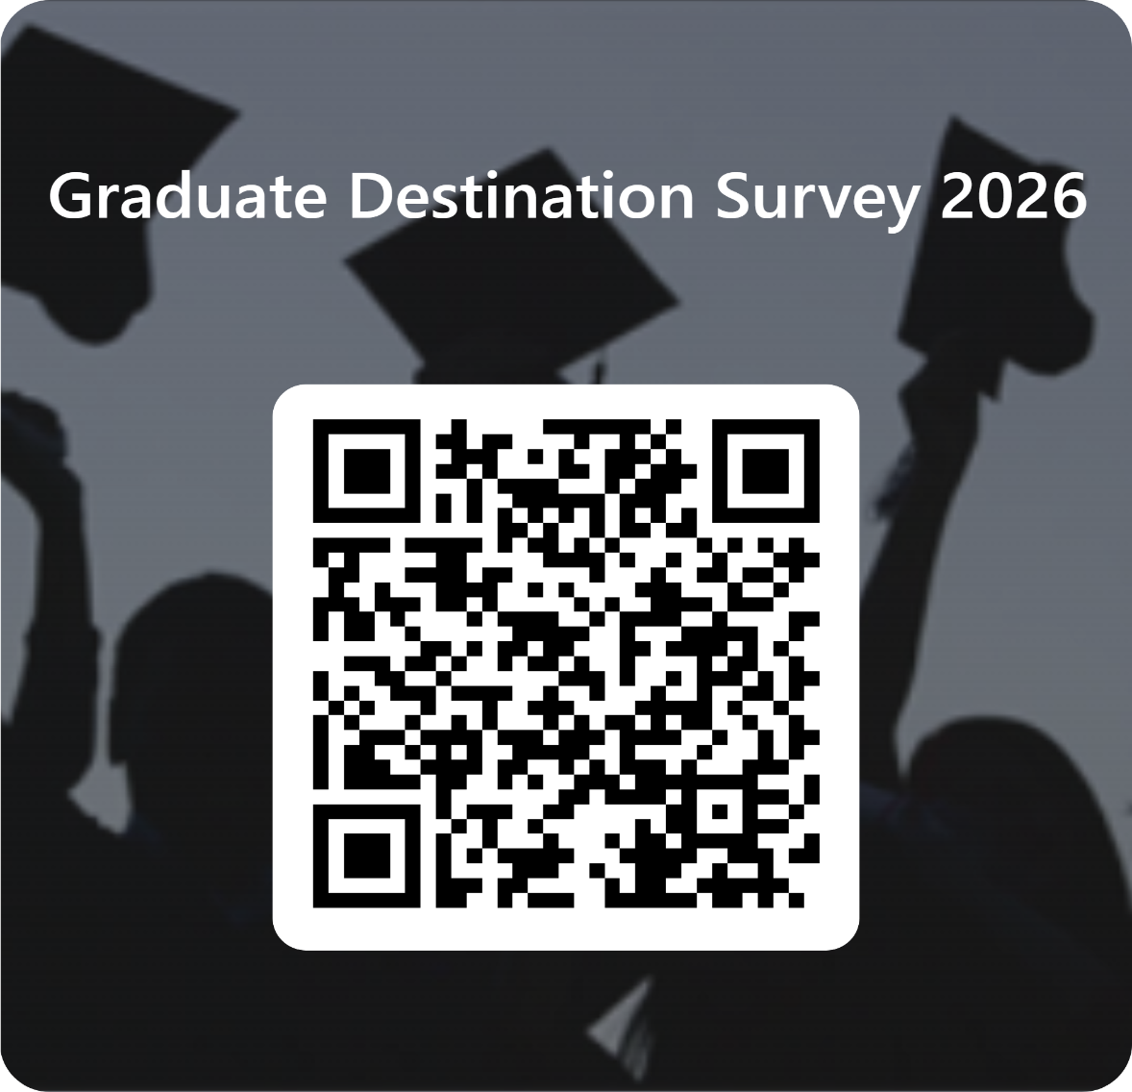

For further information regarding the graduation ceremonies, please visit the iYunivesithi Walter Sisulu website.
Walter Sisulu looks forward to celebrating this important achievement with you.

GRADUATION SCHEDULE PER FACULTY, PER SESSION

MTHATHA CAMPUS – NMD, GREAT HALL
DAY 1  FRIDAY, 25 SEPT 2026 | FACULTIES | MORNING SESSION
DAY 1  FRIDAY, 25 SEPT 2026 | - FACULTY OF MANAGEMENT AND PUBLIC ADMINISTRATION SCIENCES  - FACULTY OF EDUCATION  - FACULTY OF LAW, HUMANITIES AND SOCIAL SCIENCES | 08:00
DAY 1  FRIDAY, 25 SEPT 2026 | FACULTIES | AFTERNOON SESSION
DAY 1  FRIDAY, 25 SEPT 2026 | - FACULTY OF ECONOMIC AND FINANCIAL SCIENCES  - FACULTY OF MEDICINE AND HEALTH SCIENCES  - FACULTY OF NATURAL SCIENCES  - FACULTY OF ENGINEERING, BUILT ENVIRONMENT & INFORMATION TECHNOLOGY | 13:00

Issued by the:

Dr Lulamile Ntonzima
University Registrar

