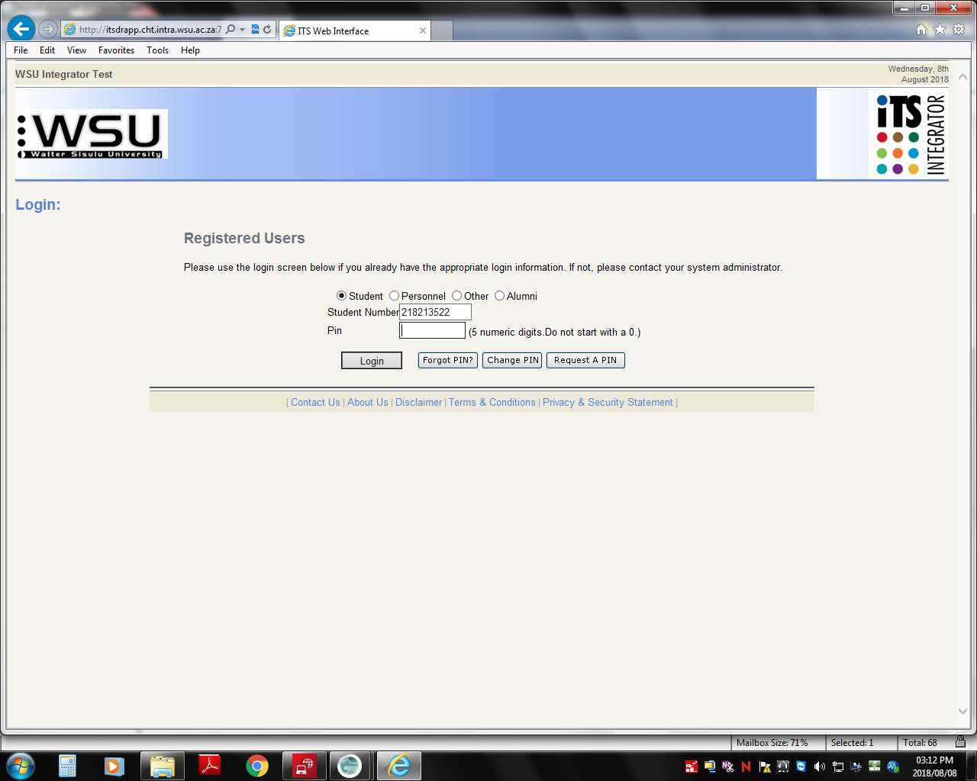

**Instructions:**

1. The student must enter/capture his/her student number in the block provided for this number above.
2. Then he/she will enter/capture his/her PIN number which will has been sent to his/her email account.
3. The system will immediately transfer to the next page below.

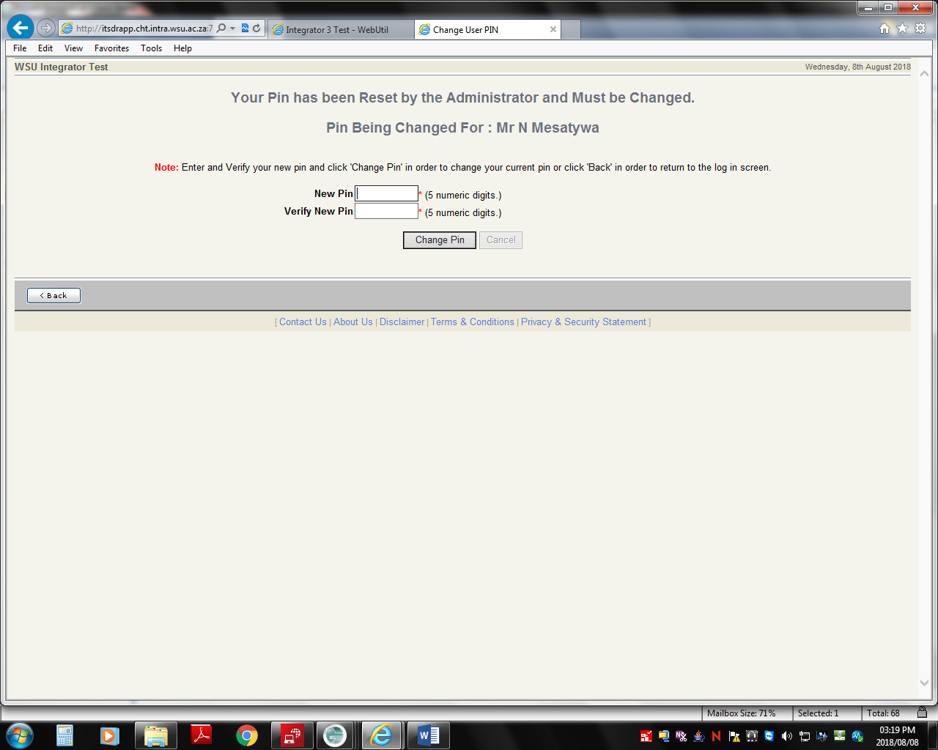

**Instructions:**

1. On this page you are required to create your own PIN which should be numeric and verify it and then click change PIN to save

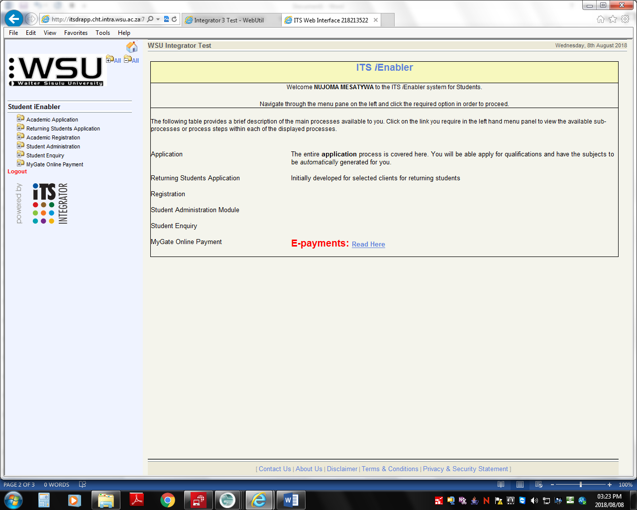

**Instructions:**

You must now click on the business function indicated by the arrow. It opens 2 sub functions/activities namely POPI and Retuning Students Applications see the below picture.

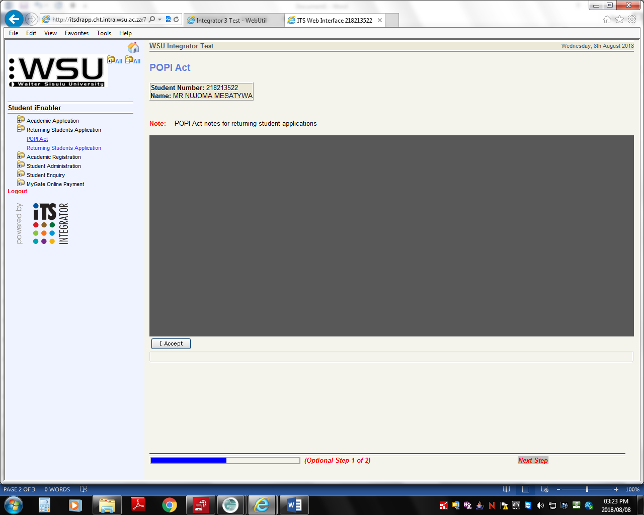

**Instructions:**

Read the POPI Act rules and click on “I Accept” if you agree. The Click on “Returning Student Application” to proceed to the next page.

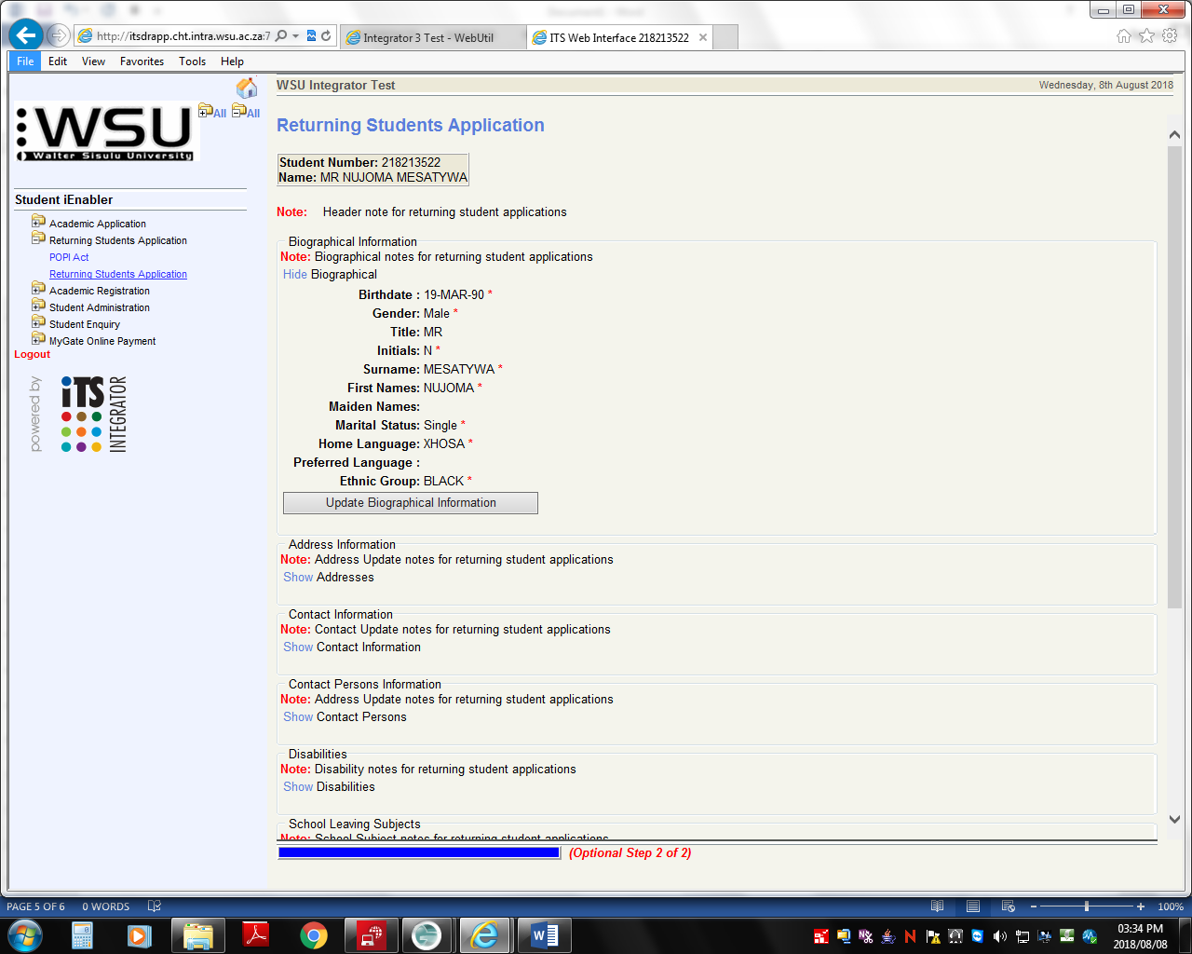

**Instructions:**

This page contains all the student’s personal information just click on the blue “Show” and the information will display.

**You can check:**

Address information

Contact information, etc

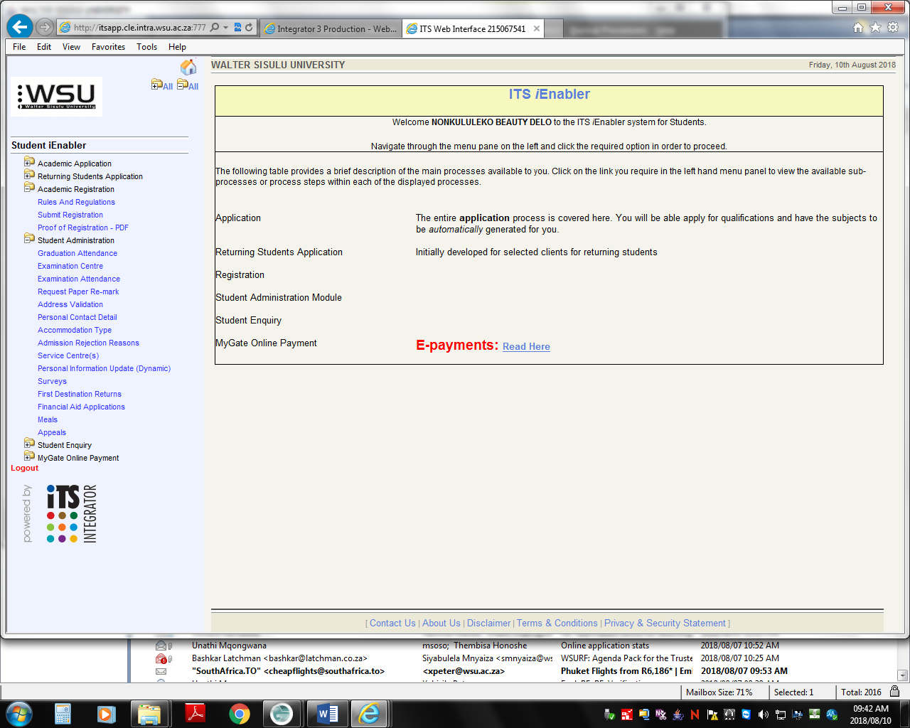

**Instructions:**

If you click on the various business function options (black ink) you will be directed to the sub-functions

(blue ink). These are the services that you can access. Some are currently not functioning because certain settings are been done. In other instances the process period has not come yet e.g. Academic Registration

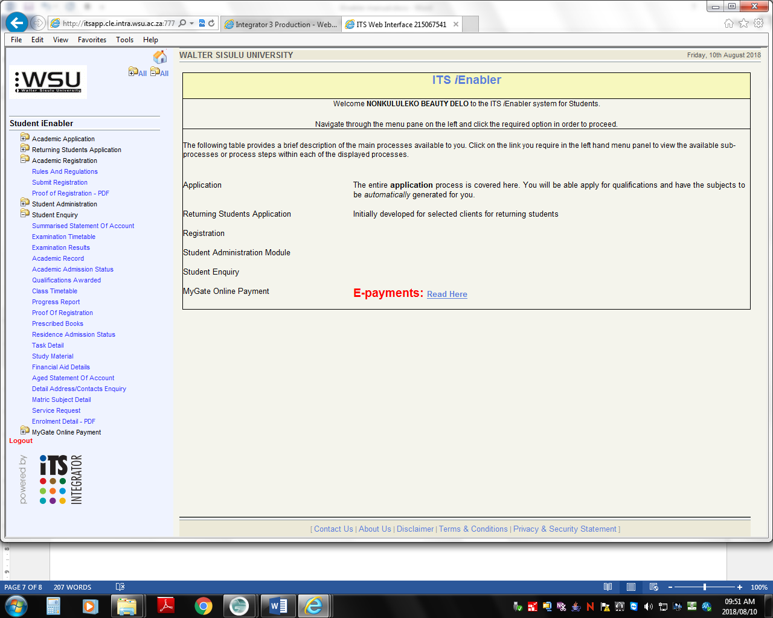

**Instructions:**

If you click on the various business function options (black ink) you will be directed to the sub-functions

(blue ink). These are the services that you can access. Some are currently not functioning because certain settings are been done. In other instances the process period has not come yet e.g. Academic Registration