**Step by Step Guide for Staff and Students to access online Lecturing Timetables**

1. Click on the URL link as provided to you.
2. The Home page is displayed and defaults to the current month and year.

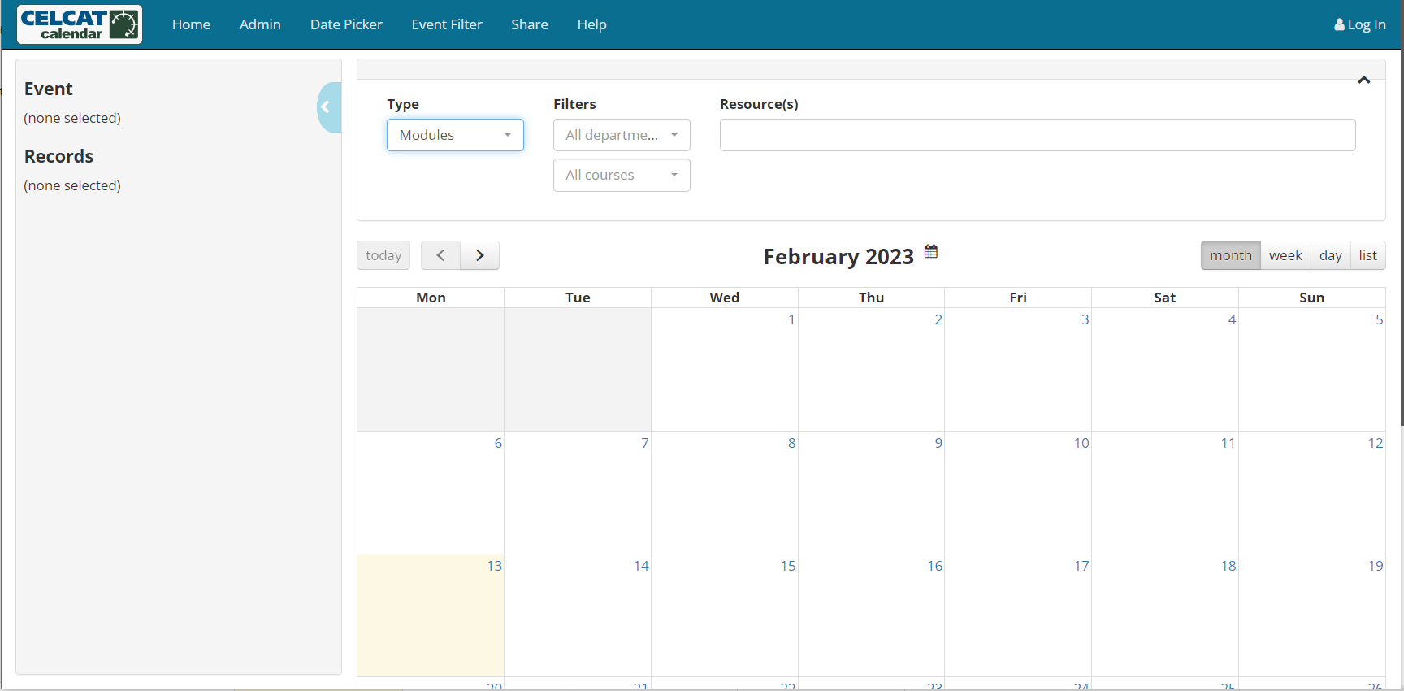

1. Select from the drop-down lists what timetable information you want to see.

**For Students:**

Step 1:Select **Groups** as the Resource **Type** from the drop-down list

Step 2: Filter to the relevant department by typing at least the first letter of the department name (optional step)

Step 3: Select the relevant qualification in the **Resources** text box by typing either of the following:

* a ‘**#’**-key to bring up all the qualifications offered by the selected department (if chosen)
* part of the qualification name
* beginning of the actual qualification code (Remember to include a ‘#’ in front of the code)

**For Staff:**

Follow the same steps as for students. You may choose to select a difference resource type from the drop-down **Type** list.

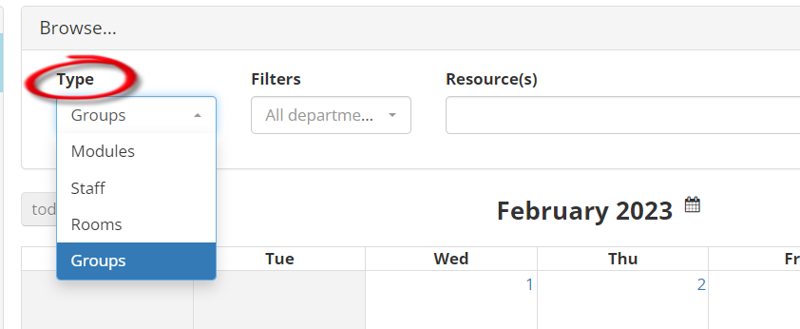

1. You may select to view your timetable according to a month/week/day or list view.

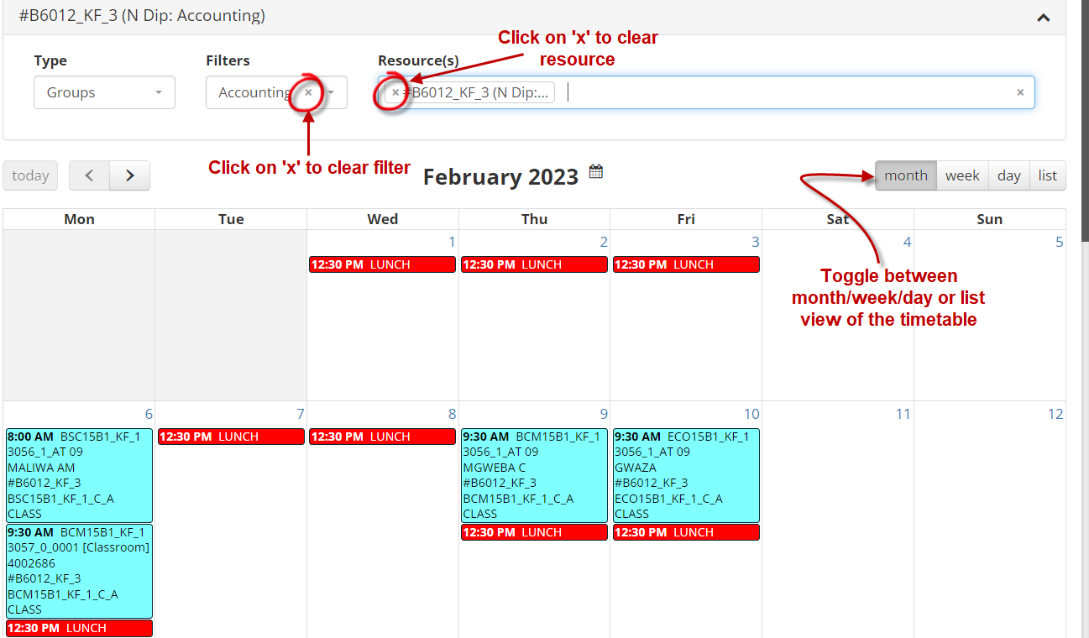

1. To expand the information of an event on the timetable grid, left click the event.

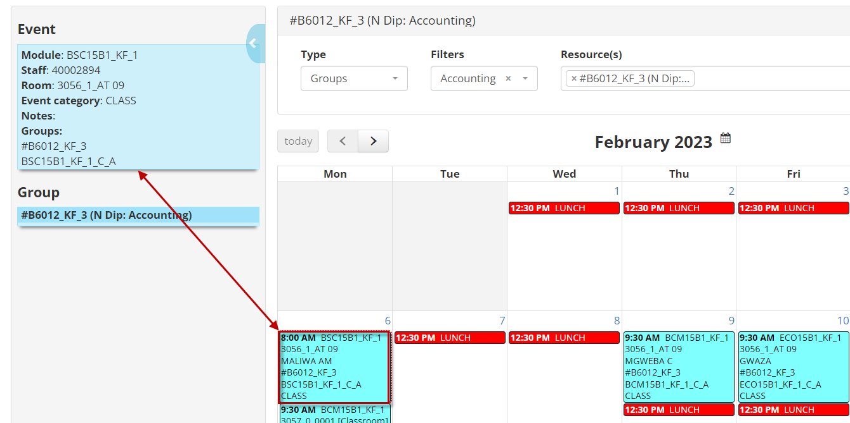

1. The smart key at the bottom of the page is an indication of the event category type, for example, Class, Tutorial, Practical or Lunch and has been colour-coded accordingly.

